**VPC NAT Gateway  
--------------------**

1) Create one VPC,with 1 one public subnet and 1 private subnet.

First, you have to create a VPC

* *Go to, VPC console*
* *Click the Create VPC option*
* *In VPC, select the VPC option only*
* *Name the VPC*
* *Give ipv4 address 🡪 mention ipv4 address as 192.168.0.0/24 🡪 because whole VPC has it ipv4 address*
* *Go to bottom, create a vpc*

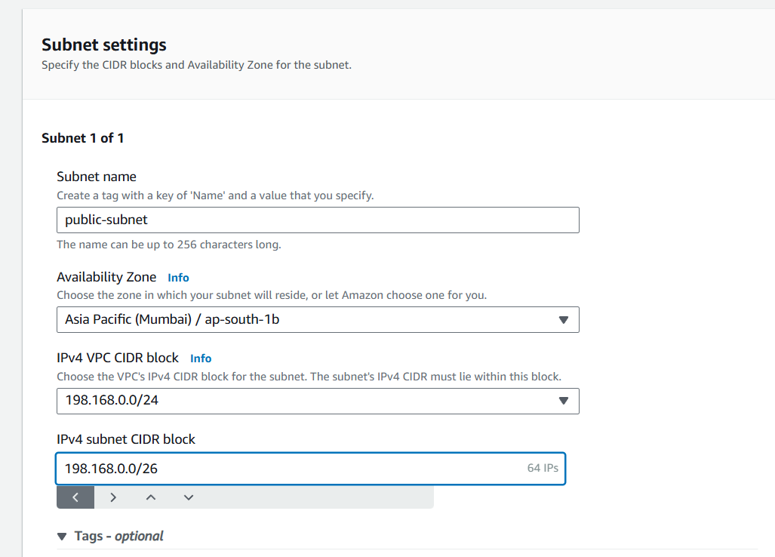

* *Go to, subnet -> create subnet*
* *Name your subnet as public and the availability zone as your instance running region*
* *Mention ipv4 subnet CIDR block*
  + *In public, subnet should start with 192.168.0.0/28 , 🡪/28 is the subnet mask in that 64 ip address running.*
  + *We have subnet mask up to /16 to /32.*
  + *In that we have configured the range of ipv4 address.*
  + *In private, subnet should starts with 192.168.0.16/28 🡪 16 is the first range to private subnet.*
  + *Because, public subnet takes 0 to 14 ip address.*
  + *So, private subnet starts after the public subnet ip address.*
  + *In aws 5 ip address has taken by aws management for maintenance to the servers*
  + *After creating the subnets for public and private.*

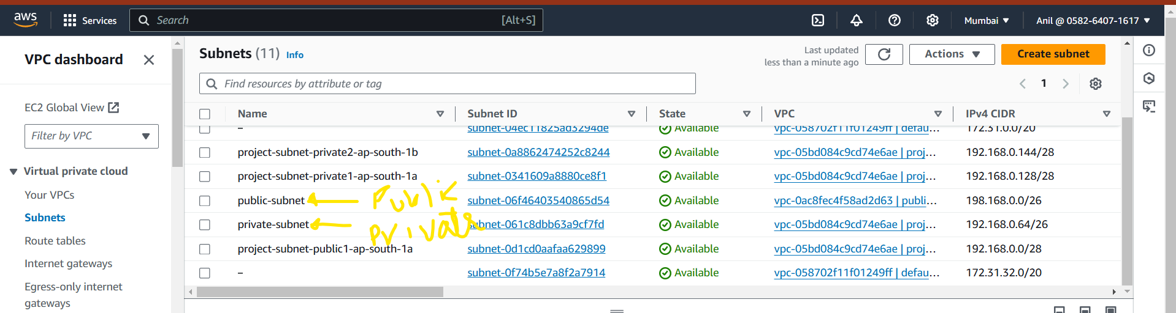

2) Enable VPC peering for cross region.

• **Log in to the AWS Management Console**: Go to the [AWS Management Console](https://docs.aws.amazon.com/vpc/latest/peering/create-vpc-peering-connection.html).

• **Navigate to the VPC Dashboard**: In the services menu, search for "VPC" and click on it to go to the VPC Dashboard.

• **Create VPCs in Each Region**: Ensure you have the necessary VPCs in each region, with unique CIDR blocks.

• **Create VPC Peering Connection**:

In the VPC Dashboard, click on "Peering Connections" in the left sidebar.

Click on the "Create Peering Connection" button.

Provide the following details:

**Name tag**: Give your peering connection a name.

**VPC ID (Requester)**: Select the VPC in your account that will initiate the peering.

**Peer VPC ID (Accepter)**: Select the VPC in the other region that will accept the peering request.

Click "Create Peering Connection".

• **Accept the Peering Request**:

Go to the "Peering Connections" section in the VPC Dashboard.

Find the peering connection you just created and click on "Actions" -> "Accept Request".

Confirm the acceptance.

• **Update Route Tables**:

In the VPC Dashboard, click on "Route Tables" in the left sidebar.

Select the route table associated with your VPCs.

Click on "Routes" and then "Edit routes".

Add a route for the peer VPC’s CIDR block, pointing to the peering connection.

Click "Save routes".

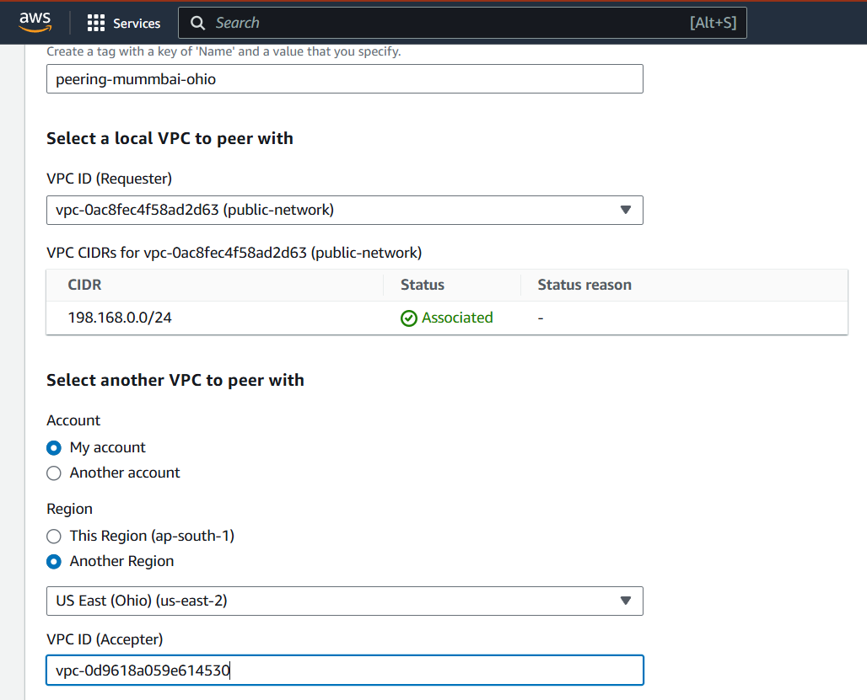



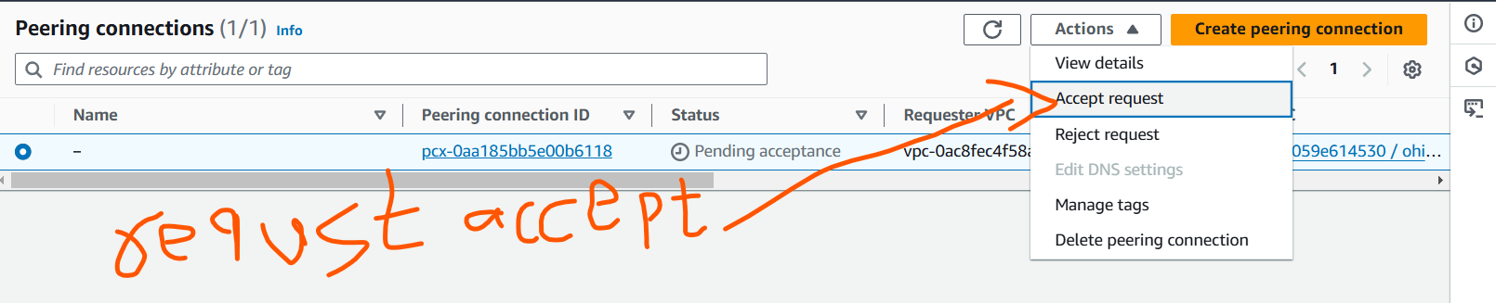

3) Enable VPC peering for cross account.

• **Log in to the AWS Management Console**: Go to the [AWS Management Console](https://docs.aws.amazon.com/vpc/latest/peering/create-vpc-peering-connection.html).

• **Navigate to the VPC Dashboard**: In the services menu, search for "VPC" and click on it to go to the VPC Dashboard.

• **Create VPCs in Each Region**: Ensure you have the necessary VPCs in each region, with unique CIDR blocks.

• **Create VPC Peering Connection**:

In the VPC Dashboard, click on "Peering Connections" in the left sidebar.

Click on the "Create Peering Connection" button.

Provide the following details:

**Name tag**: Give your peering connection a name.

**VPC ID (Requester)**: Select the VPC in your account that will initiate the peering.

**Peer VPC ID (Accepter)**: Select the VPC in the other region that will accept the peering request.

Click "Create Peering Connection".

• **Accept the Peering Request**:

Go to the "Peering Connections" section in the VPC Dashboard.

Find the peering connection you just created and click on "Actions" -> "Accept Request".

Confirm the acceptance.

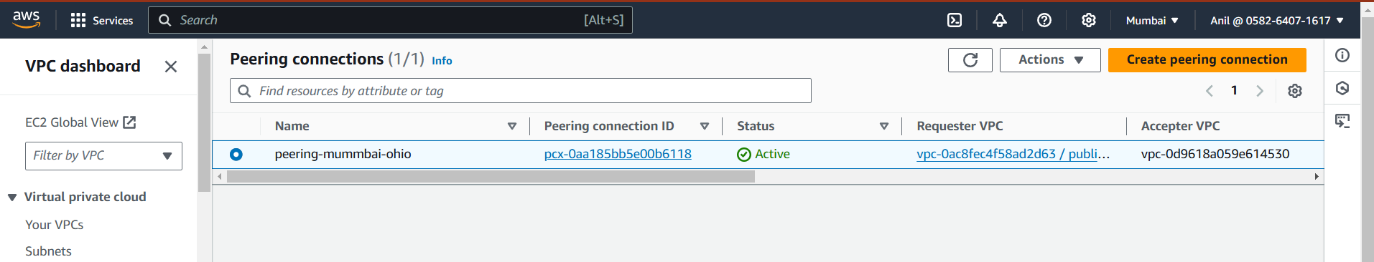

• **Update Route Tables**:

In the VPC Dashboard, click on "Route Tables" in the left sidebar.

Select the route table associated with your VPCs.

Click on "Routes" and then "Edit routes".

Add a route for the peer VPC’s CIDR block, pointing to the peering connection.

Click "Save routes".



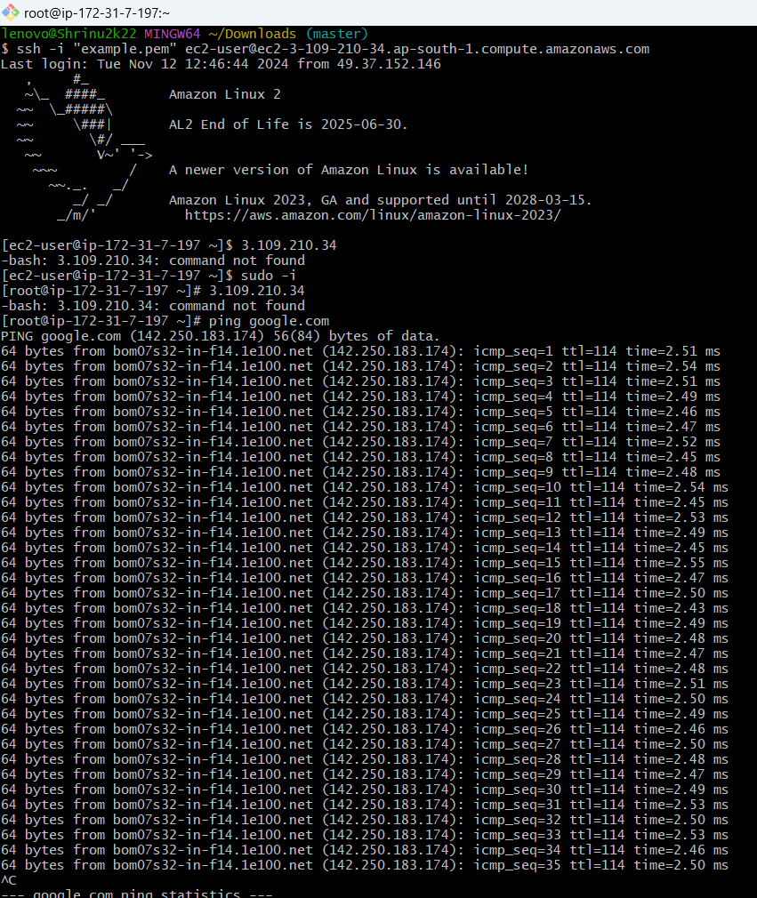

4) Setup VPC Transist gateway.

1. Create the Transit Gateway

1. Log in to AWS Console:
   * Open the AWS Management Console and go to the VPC Dashboard.
2. Navigate to Transit Gateways:
   * In the left-hand menu, under the Transit Gateway section, click Create Transit Gateway.
3. Configure Transit Gateway Settings:
   * Name: Provide a descriptive name for your Transit Gateway (e.g., My-Transit-Gateway).
   * Description: Optionally provide a description.
   * Amazon ASN: Choose a unique ASN (Autonomous System Number) for the Transit Gateway. By default, AWS assigns a value, but you can customize it if necessary (recommended range is between 64512 and 65534).
   * Default Route Table Association: Decide whether to associate new VPCs with the default route table.
   * Default Route Table Propagation: Decide whether to automatically propagate routes to new VPCs attached to the Transit Gateway.
   * DNS Support: Choose whether to enable DNS support. Enable this if you want private DNS resolution across VPCs connected to the Transit Gateway.
   * Multicast: Enable multicast if required for your use case (typically not needed for most VPC-to-VPC communications).
4. Create Transit Gateway:
   * Click Create Transit Gateway to initiate the creation.

